1. Demo with a simple web page to show payment using Stripe billing subscription API and show successful payment for a daily subscription.

User signup

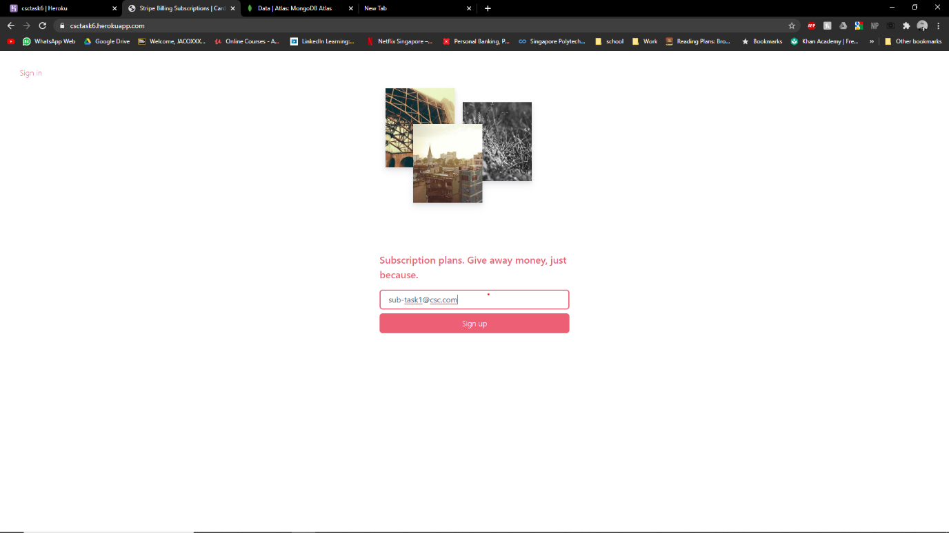

User select Good plan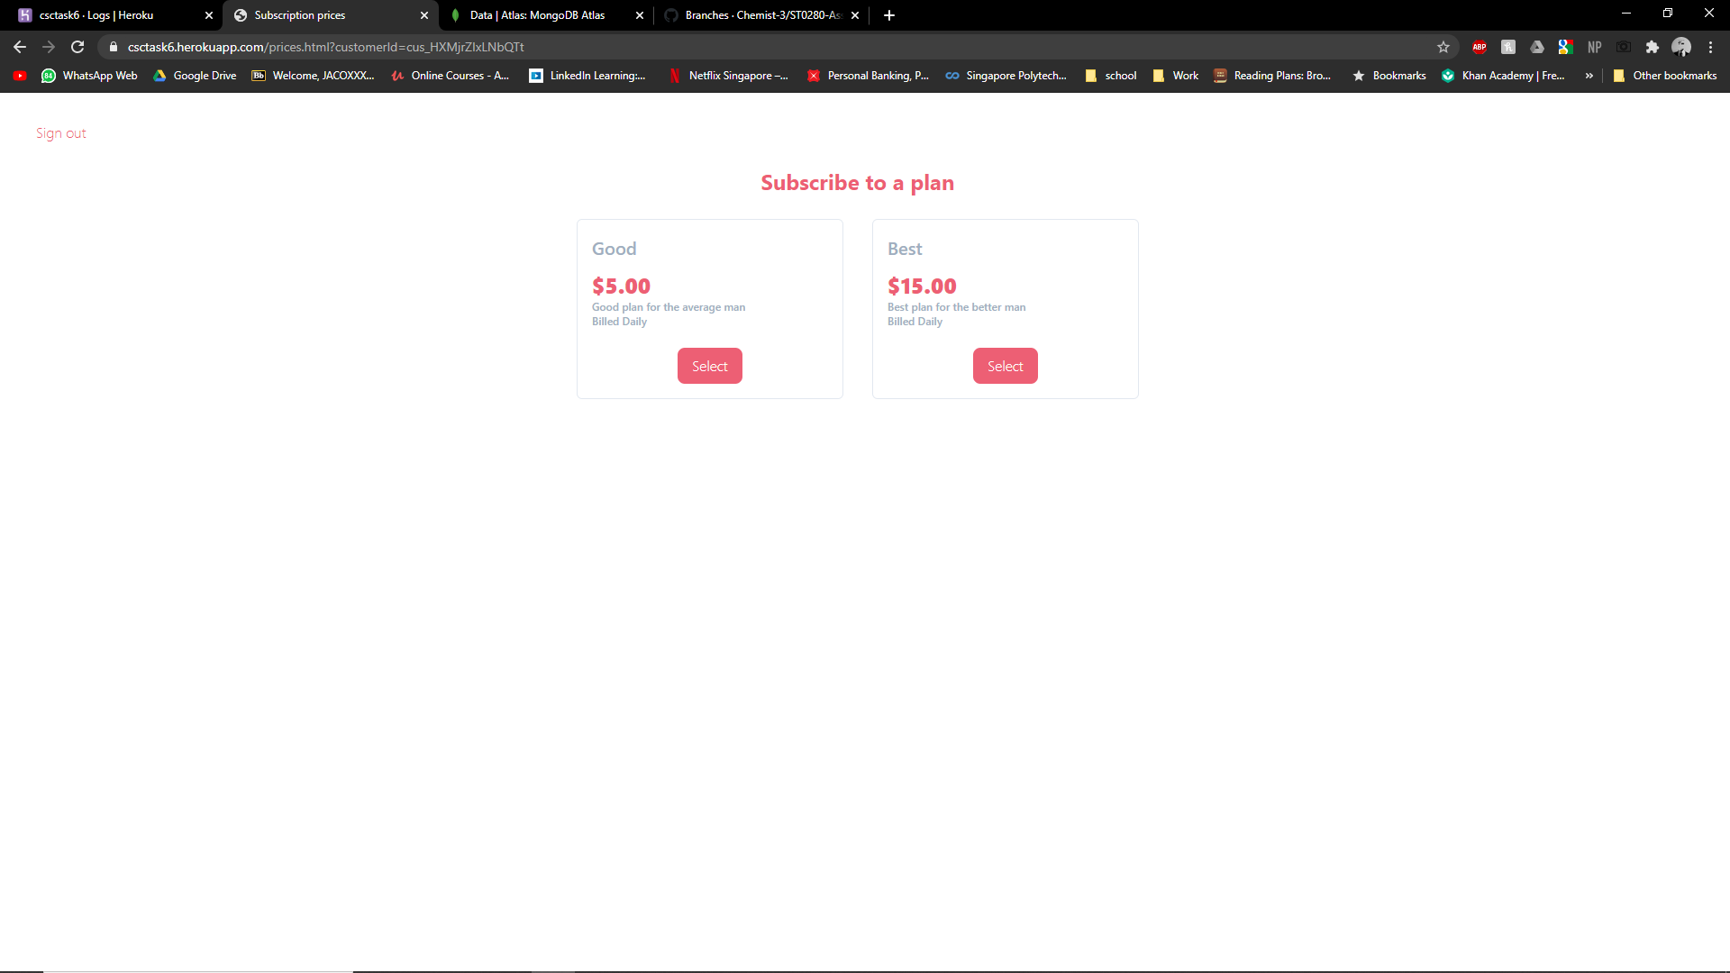

User input credit card details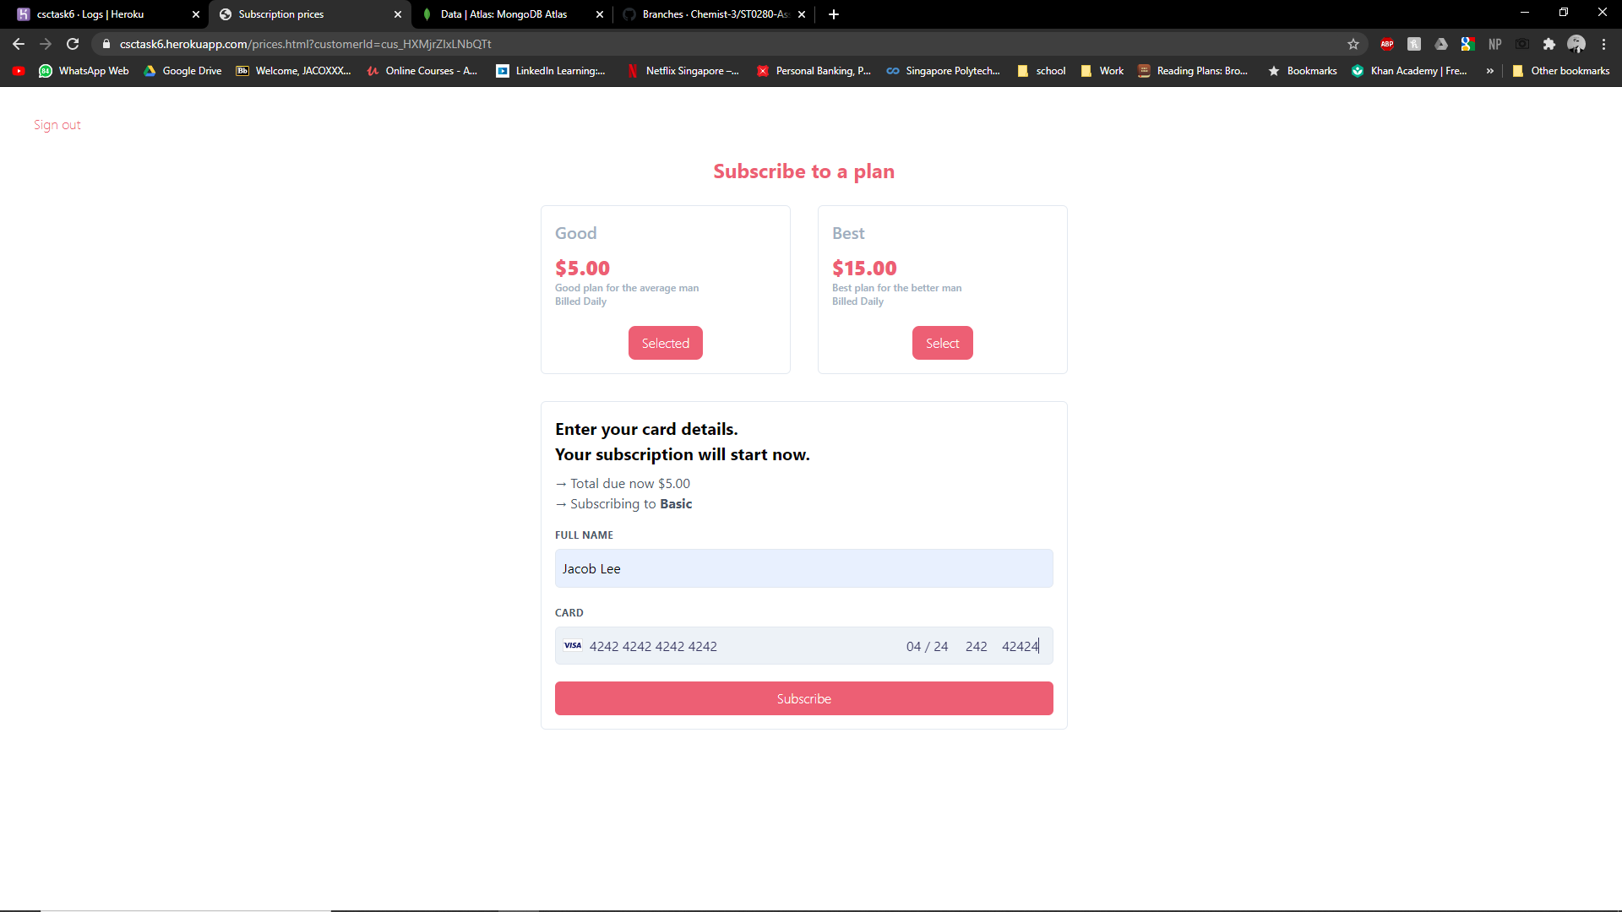

Payment completed

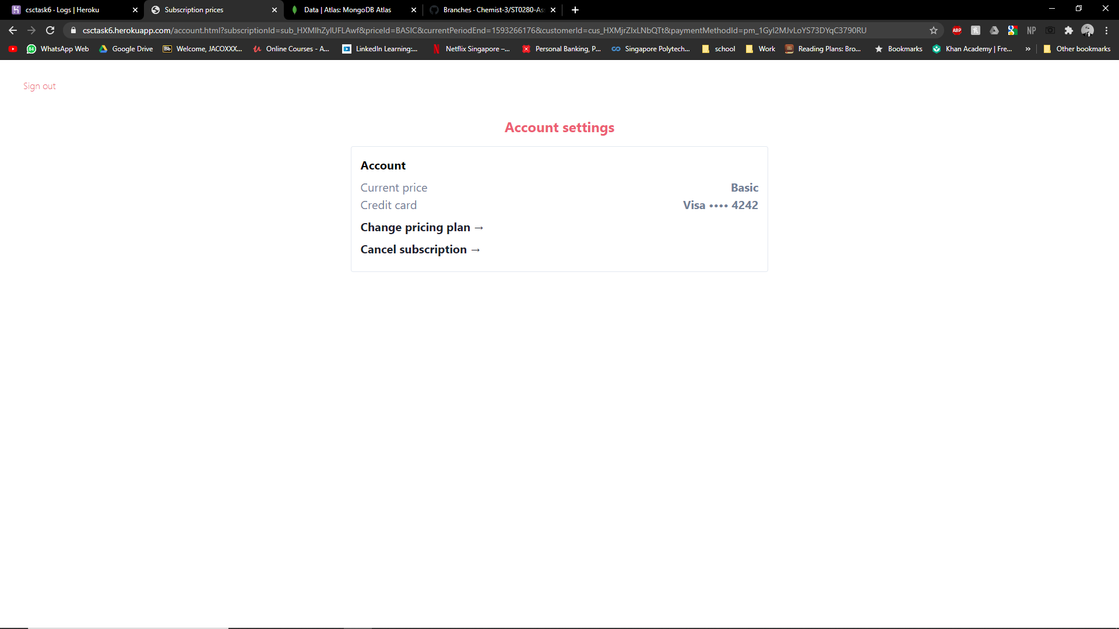

1. Demo at least 3 consecutive days of recurring subscription charges.

Here u can see the initial charge then second charge and the future one. Because stripe cannot change time and date for the system I cant demo the third day charge

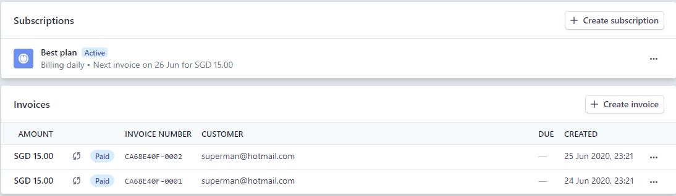

1. Demo Stripe subscription webhook to update database on success or failure to charge subscription

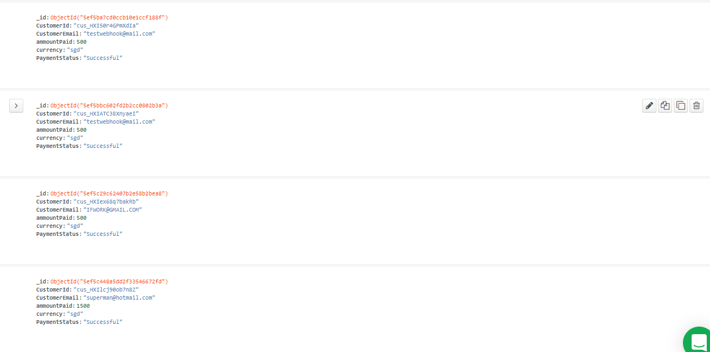

1. Demo using your web page to change Stripe subscription plan i.e. upgrade, downgrade, cancel, and next payment

User upgrades to best plan

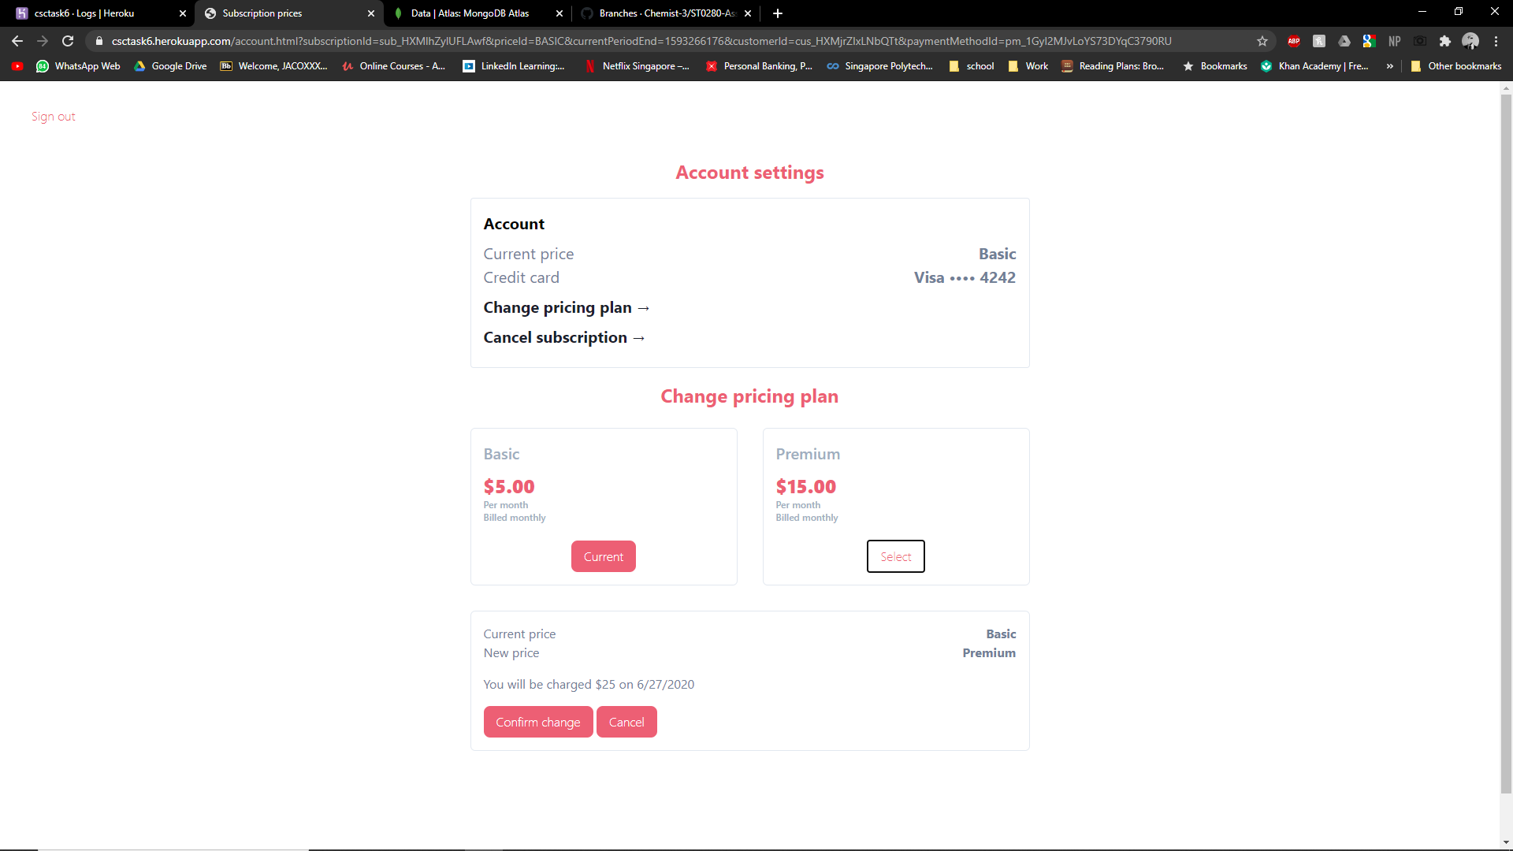

Upgrade complete

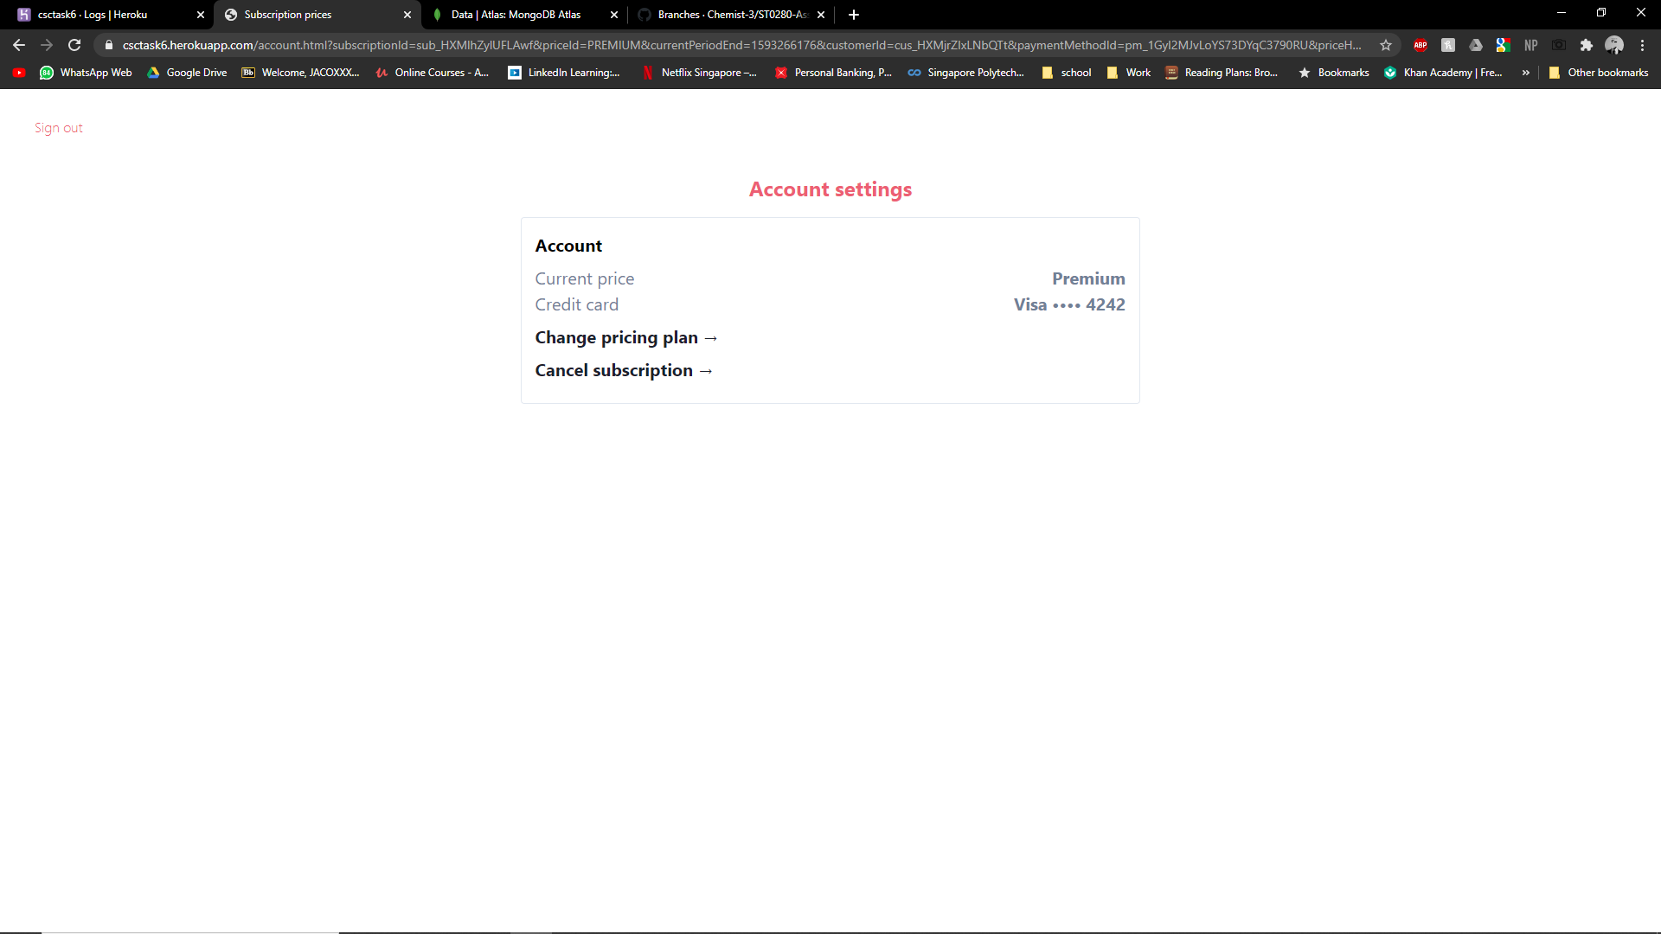

User downgrade plan

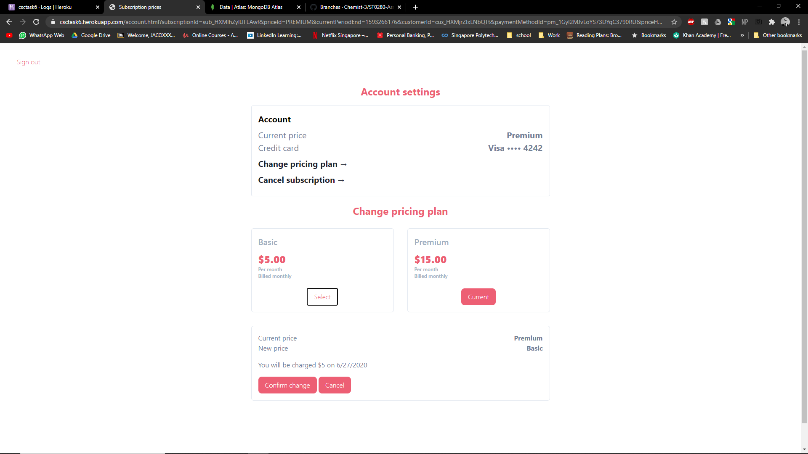

Downgrade complete

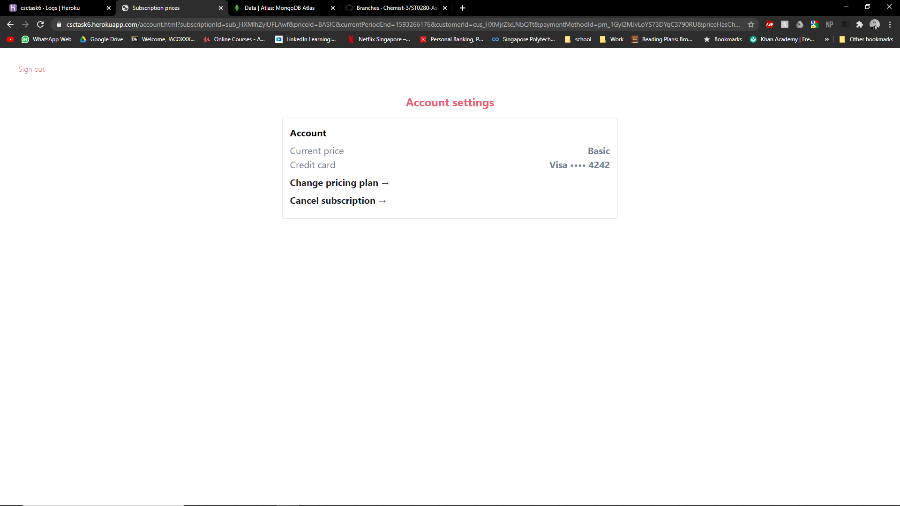

1. Demo refund and pause payment

Process refund

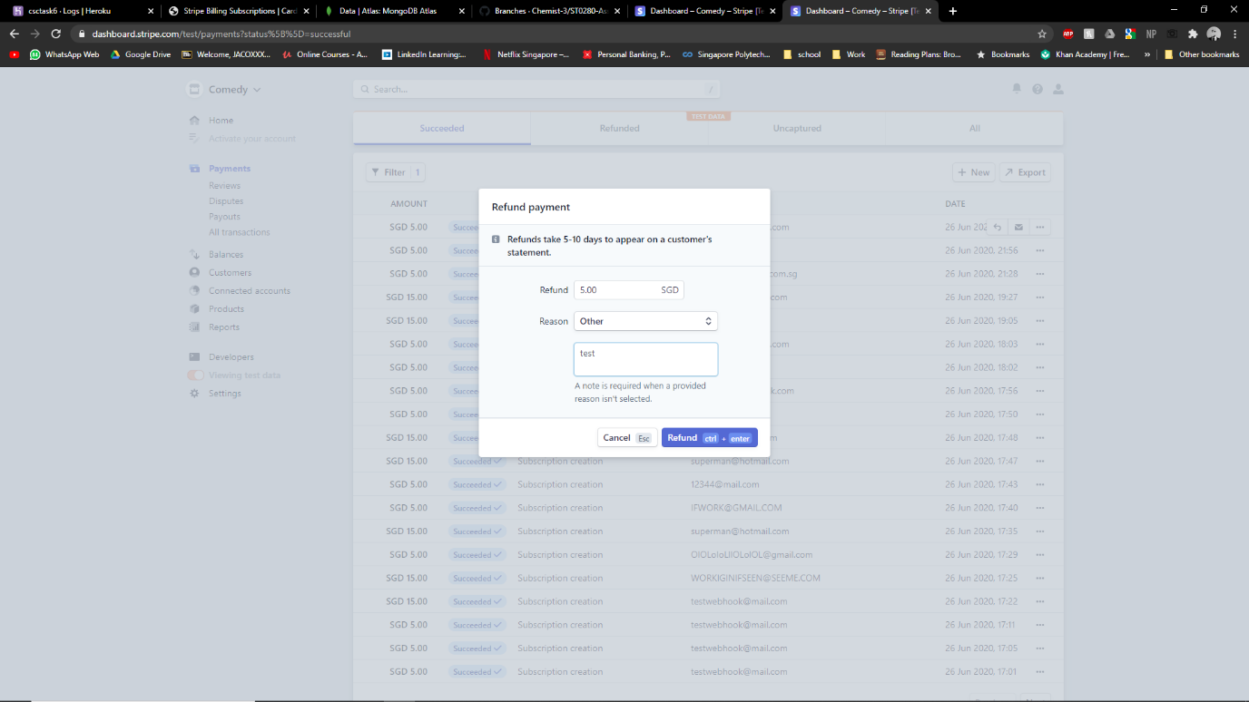

Refund complete

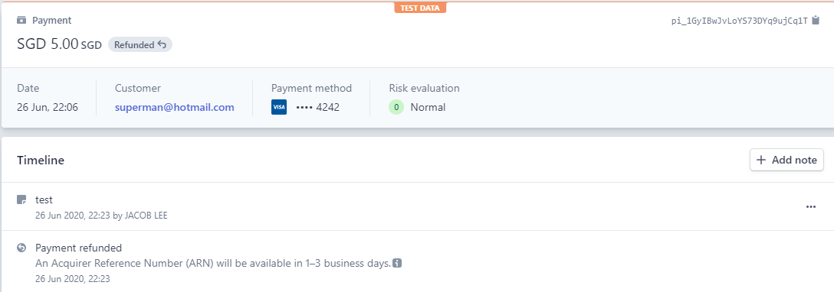

Pause subscription

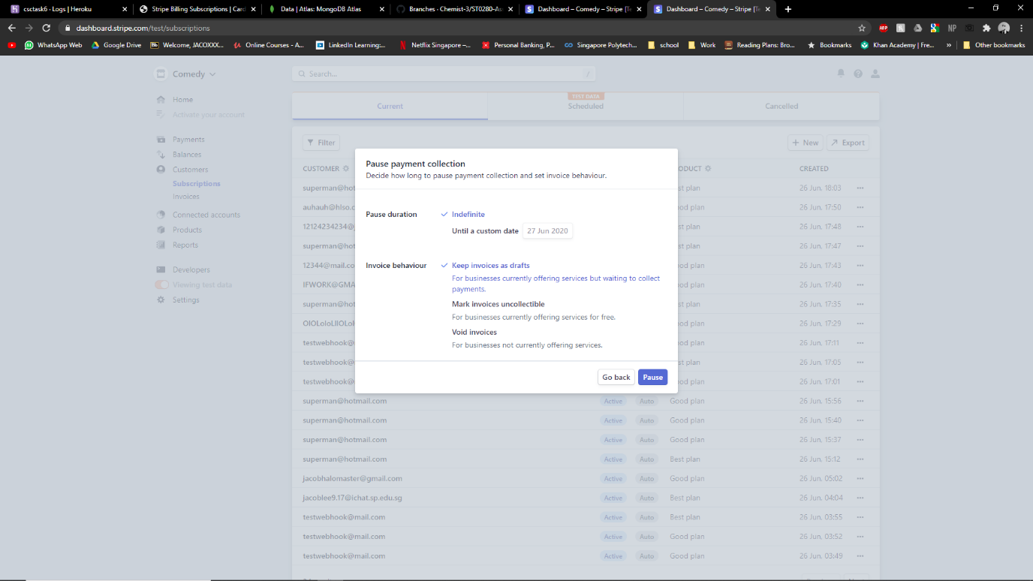

Pause successful

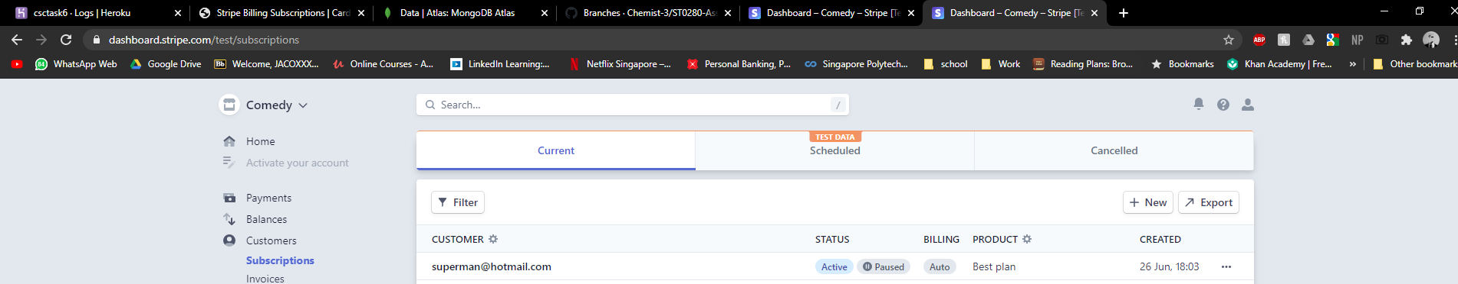

1. On changes to Stripe subscription such as successful charges, failure, and changes, use Stripe webhook to update your database. You can use Database-as-a-Service,

Here we can see if the user chooses to upgrade or downgrade the plan, It is denoted as SubscriptionStatus: Updated

Canceled subscription will be

SubscriptionStatus: deleted

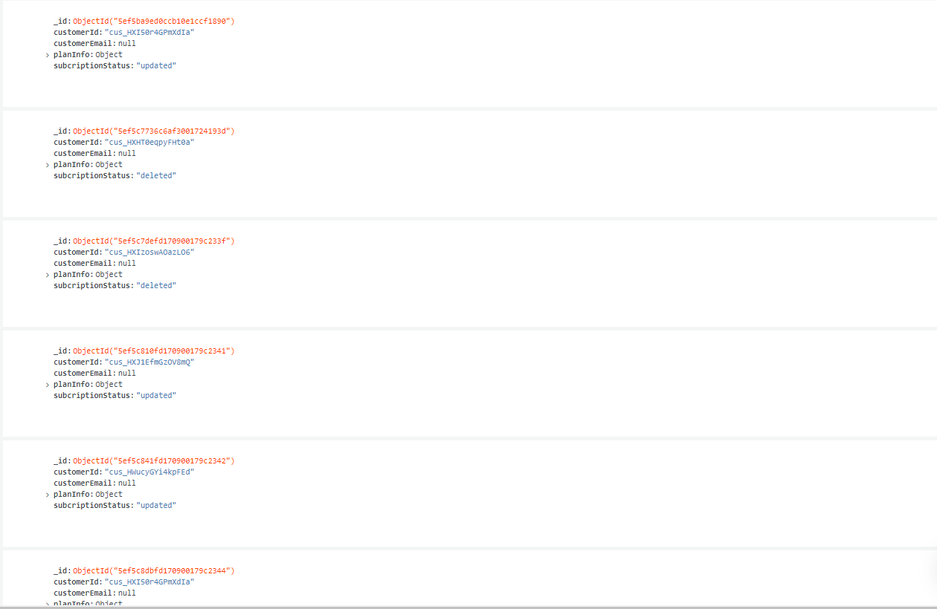

1. Sequence diagram in sequence diagram folder